**Trade Aggregation**

1. Create database

We have created a database named **capstoneproject**.

**Trade Model:**

Cancel_trade Model:

1. Creation of Validation Models

**Inserting data for table `institution`**

INSERT INTO `institution` VALUES (1,'HDFC');

INSERT INTO `institution` VALUES (2,'SBI');

**Inserting data for table `party`**

INSERT INTO `party` VALUES (1,1,'HDFC_MUMBAI','HDFCM'),

INSERT INTO `party` VALUES (2,2,'SBI_DELHI','SBID');

**SCHEMA**

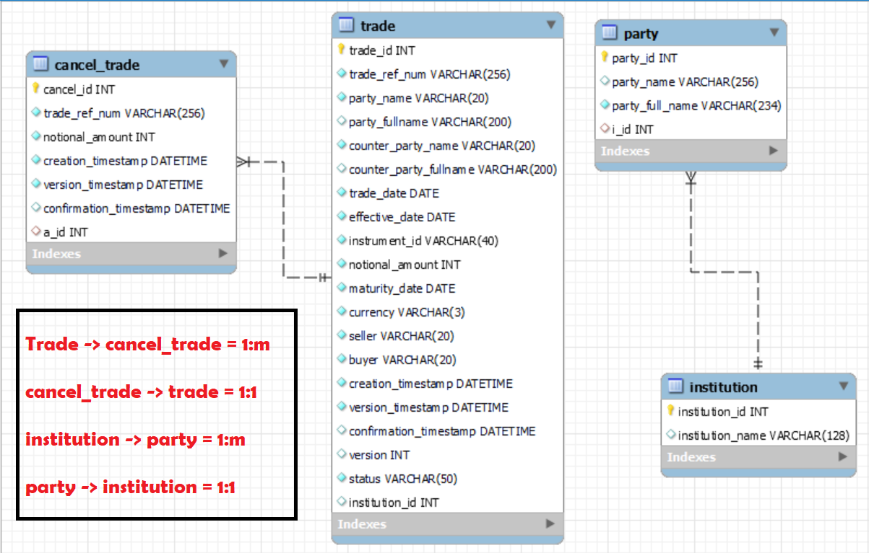

**For Validation**

We have created Party and Institution table for validation.

We have used institution_id(i_id) as foreign key in our Party table for connection.

**For Aggregation and Cancellation Trade**

We have created Cancel table for storing all the cancelled trades after aggregation.